МИНИСТЕРСТВО НАУКИ И ВЫСШЕГО ОБРАЗОВАНИЯ РОССИЙСКОЙ ФЕДЕРАЦИИ
федеральное государственное бюджетное образовательное учреждение высшего образования
«УЛЬЯНОВСКИЙ ГОСУДАРСТВЕННЫЙ ТЕХНИЧЕСКИЙ УНИВЕРСИТЕТ»

Факультет информационных систем и технологий
Кафедра: «Измерительно-вычислительные комплексы»
Дисциплина: «Протоколы и интерфейсы информационных систем»

Отчёт
По лабораторной работе №2
по теме: «Передача данных по протоколу MQTT»

Выполнил:
студент гр. ИСТбд-32
Камаев М.Р

Ульяновск,
2026 г.

Тема: Передача данных по протоколу MQTT.

Цель:
Целью работы является изучение протокола MQTT и получение практических навыков публикации и приёма сообщений между клиентами по модели издатель-подписчик.

ЗАДАНИЕ 1
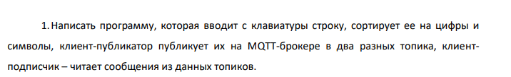
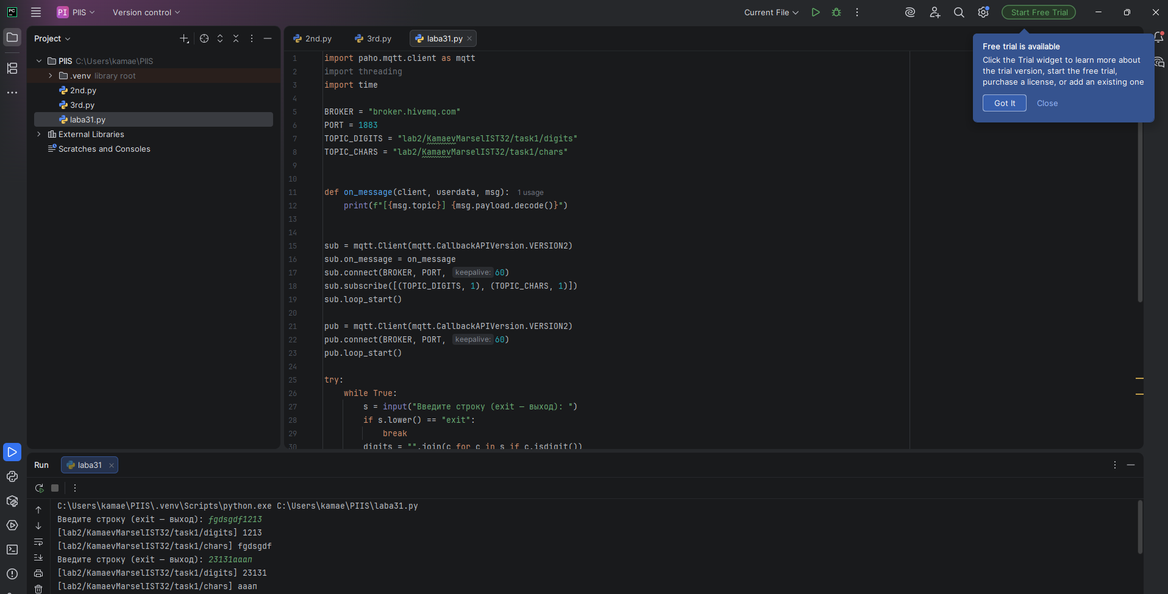
Код:
import paho.mqtt.client as mqtt
import threading
import time

BROKER = "broker.hivemq.com"
PORT = 1883
TOPIC_DIGITS = "lab2/KamaevMarselIST32/task1/digits"
TOPIC_CHARS = "lab2/KamaevMarselIST32/task1/chars"

def on_message(client, userdata, msg):
print(f"[{msg.topic}] {msg.payload.decode()}")

sub = mqtt.Client(mqtt.CallbackAPIVersion.VERSION2)
sub.on_message = on_message
sub.connect(BROKER, PORT, 60)
sub.subscribe([(TOPIC_DIGITS, 1), (TOPIC_CHARS, 1)])
sub.loop_start()

pub = mqtt.Client(mqtt.CallbackAPIVersion.VERSION2)
pub.connect(BROKER, PORT, 60)
pub.loop_start()

try:
while True:
s = input("Введите строку (exit — выход): ")
if s.lower() == "exit":
break
digits = "".join(c for c in s if c.isdigit())
chars = "".join(c for c in s if not c.isdigit())
if digits:
pub.publish(TOPIC_DIGITS, digits, qos=1)
if chars:
pub.publish(TOPIC_CHARS, chars, qos=1)

time.sleep(0.5)
finally:
pub.loop_stop(); sub.loop_stop()
pub.disconnect(); sub.disconnect()
ЗАДАНИЕ 2
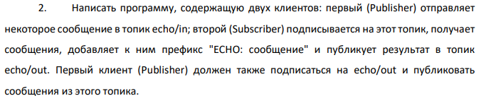
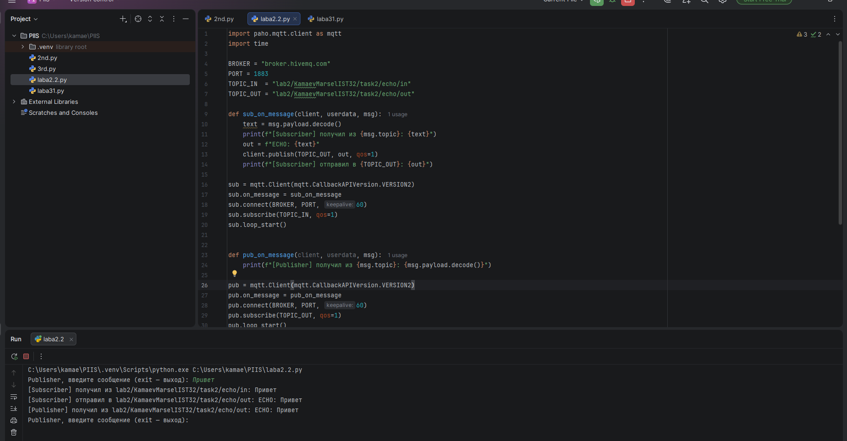

Код:
import paho.mqtt.client as mqtt
import time

BROKER = "broker.hivemq.com"
PORT = 1883
TOPIC_IN = "lab2/KamaevMarselIST32/task2/echo/in"
TOPIC_OUT = "lab2/KamaevMarselIST32/task2/echo/out"

def sub_on_message(client, userdata, msg):
text = msg.payload.decode()
print(f"[Subscriber] получил из {msg.topic}: {text}")
out = f"ECHO: {text}"
client.publish(TOPIC_OUT, out, qos=1)
print(f"[Subscriber] отправил в {TOPIC_OUT}: {out}")

sub = mqtt.Client(mqtt.CallbackAPIVersion.VERSION2)
sub.on_message = sub_on_message
sub.connect(BROKER, PORT, 60)
sub.subscribe(TOPIC_IN, qos=1)
sub.loop_start()

def pub_on_message(client, userdata, msg):
print(f"[Publisher] получил из {msg.topic}: {msg.payload.decode()}")

pub = mqtt.Client(mqtt.CallbackAPIVersion.VERSION2)
pub.on_message = pub_on_message
pub.connect(BROKER, PORT, 60)
pub.subscribe(TOPIC_OUT, qos=1)
pub.loop_start()

try:
while True:
text = input("Publisher, введите сообщение (exit — выход): ")
if text.lower() == "exit":
break
pub.publish(TOPIC_IN, text, qos=1)
time.sleep(1)
finally:
sub.loop_stop(); pub.loop_stop()
sub.disconnect(); pub.disconnect()

ЗАДАНИЕ 3
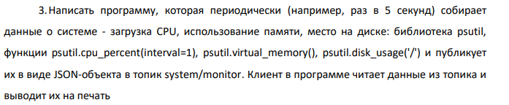
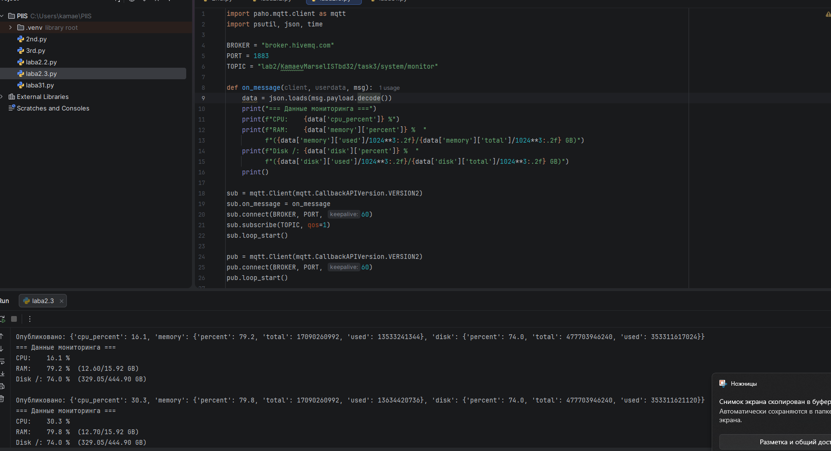
Код:
import paho.mqtt.client as mqtt
import psutil, json, time

BROKER = "broker.hivemq.com"
PORT = 1883
TOPIC = "lab2/KamaevMarselISTbd32/task3/system/monitor"

def on_message(client, userdata, msg):
data = json.loads(msg.payload.decode())
print("=== Данные мониторинга ===")
print(f"CPU: {data['cpu_percent']} %")
print(f"RAM: {data['memory']['percent']} % "
f"({data['memory']['used']/1024**3:.2f}/{data['memory']['total']/1024**3:.2f} GB)")
print(f"Disk /: {data['disk']['percent']} % "
f"({data['disk']['used']/1024**3:.2f}/{data['disk']['total']/1024**3:.2f} GB)")
print()

sub = mqtt.Client(mqtt.CallbackAPIVersion.VERSION2)
sub.on_message = on_message
sub.connect(BROKER, PORT, 60)
sub.subscribe(TOPIC, qos=1)
sub.loop_start()

pub = mqtt.Client(mqtt.CallbackAPIVersion.VERSION2)
pub.connect(BROKER, PORT, 60)
pub.loop_start()

try:
while True:
vm = psutil.virtual_memory()
disk = psutil.disk_usage('/')
data = {
"cpu_percent": psutil.cpu_percent(interval=1),
"memory": {"percent": vm.percent, "total": vm.total, "used": vm.used},
"disk": {"percent": disk.percent, "total": disk.total, "used": disk.used}
}
pub.publish(TOPIC, json.dumps(data), qos=1)
print("Опубликовано:", data)
time.sleep(5)
finally:
pub.loop_stop(); sub.loop_stop()
pub.disconnect(); sub.disconnect()
ЗАДАНИЕ 4
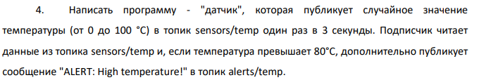
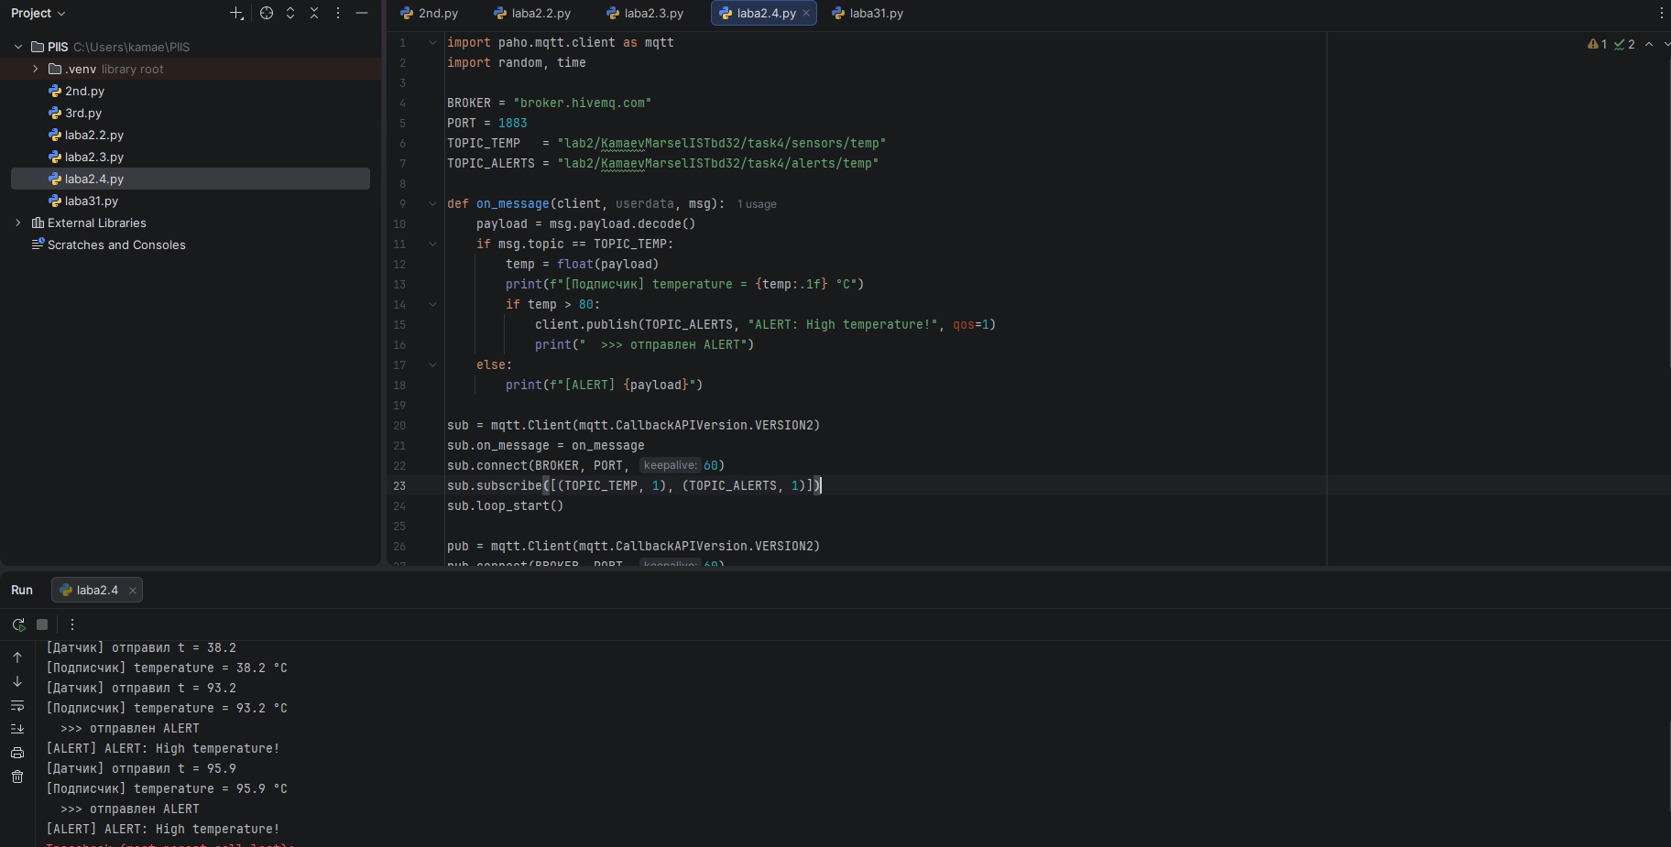
Код:
import paho.mqtt.client as mqtt
import random, time

BROKER = "broker.hivemq.com"
PORT = 1883
TOPIC_TEMP = "lab2/KamaevMarselISTbd32/task4/sensors/temp"
TOPIC_ALERTS = "lab2/KamaevMarselISTbd32/task4/alerts/temp"

def on_message(client, userdata, msg):
payload = msg.payload.decode()
if msg.topic == TOPIC_TEMP:
temp = float(payload)
print(f"[Подписчик] temperature = {temp:.1f} °C")
if temp > 80:
client.publish(TOPIC_ALERTS, "ALERT: High temperature!", qos=1)
print(" >>> отправлен ALERT")
else:
print(f"[ALERT] {payload}")

sub = mqtt.Client(mqtt.CallbackAPIVersion.VERSION2)
sub.on_message = on_message
sub.connect(BROKER, PORT, 60)
sub.subscribe([(TOPIC_TEMP, 1), (TOPIC_ALERTS, 1)])
sub.loop_start()

pub = mqtt.Client(mqtt.CallbackAPIVersion.VERSION2)
pub.connect(BROKER, PORT, 60)
pub.loop_start()

try:
while True:
t = round(random.uniform(0, 100), 1)
pub.publish(TOPIC_TEMP, str(t), qos=1)
print(f"[Датчик] отправил t = {t}")
time.sleep(3)
finally:
pub.loop_stop(); sub.loop_stop()
pub.disconnect(); sub.disconnect()

ЗАДАНИЕ 5
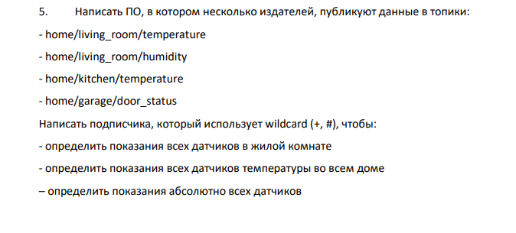
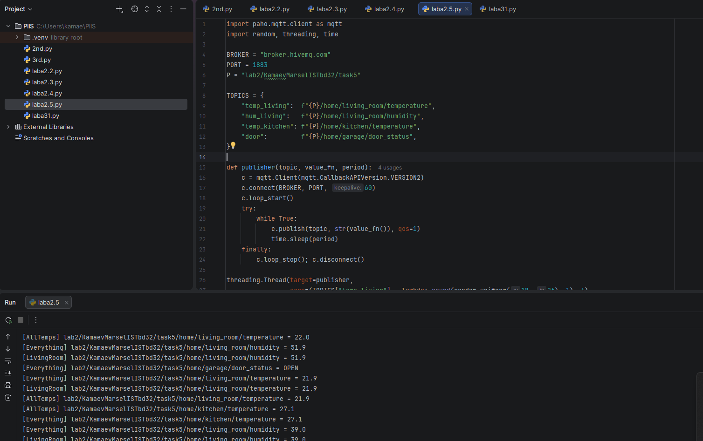
Код:
import paho.mqtt.client as mqtt
import random, threading, time

BROKER = "broker.hivemq.com"
PORT = 1883
P = "lab2/KamaevMarselISTbd32/task5"

TOPICS = {
"temp_living": f"{P}/home/living_room/temperature",
"hum_living": f"{P}/home/living_room/humidity",
"temp_kitchen": f"{P}/home/kitchen/temperature",
"door": f"{P}/home/garage/door_status",
}

def publisher(topic, value_fn, period):
c = mqtt.Client(mqtt.CallbackAPIVersion.VERSION2)
c.connect(BROKER, PORT, 60)
c.loop_start()
try:
while True:
c.publish(topic, str(value_fn()), qos=1)
time.sleep(period)
finally:
c.loop_stop(); c.disconnect()

threading.Thread(target=publisher,
args=(TOPICS["temp_living"], lambda: round(random.uniform(18, 26), 1), 4),
daemon=True).start()
threading.Thread(target=publisher,
args=(TOPICS["hum_living"], lambda: round(random.uniform(30, 60), 1), 5),
daemon=True).start()
threading.Thread(target=publisher,
args=(TOPICS["temp_kitchen"], lambda: round(random.uniform(20, 30), 1), 6),
daemon=True).start()
threading.Thread(target=publisher,
args=(TOPICS["door"], lambda: random.choice(["OPEN", "CLOSED"]), 10),
daemon=True).start()

def make_sub(name, topic_filter):
def on_msg(client, userdata, msg):
print(f"[{name}] {msg.topic} = {msg.payload.decode()}")
c = mqtt.Client(mqtt.CallbackAPIVersion.VERSION2)
c.on_message = on_msg
c.connect(BROKER, PORT, 60)
c.subscribe(topic_filter, qos=1)
c.loop_start()
return c

s1 = make_sub("LivingRoom", f"{P}/home/living_room/+")
s2 = make_sub("AllTemps", f"{P}/home/+/temperature")
s3 = make_sub("Everything", f"{P}/home/#")
try:
time.sleep(60)
finally:
for s in (s1, s2, s3):
s.loop_stop(); s.disconnect()
ЗАДАНИЕ 6
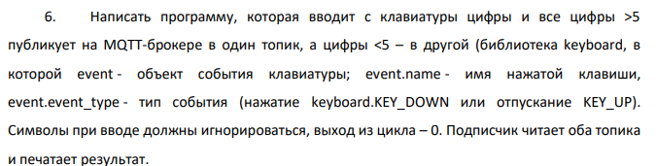
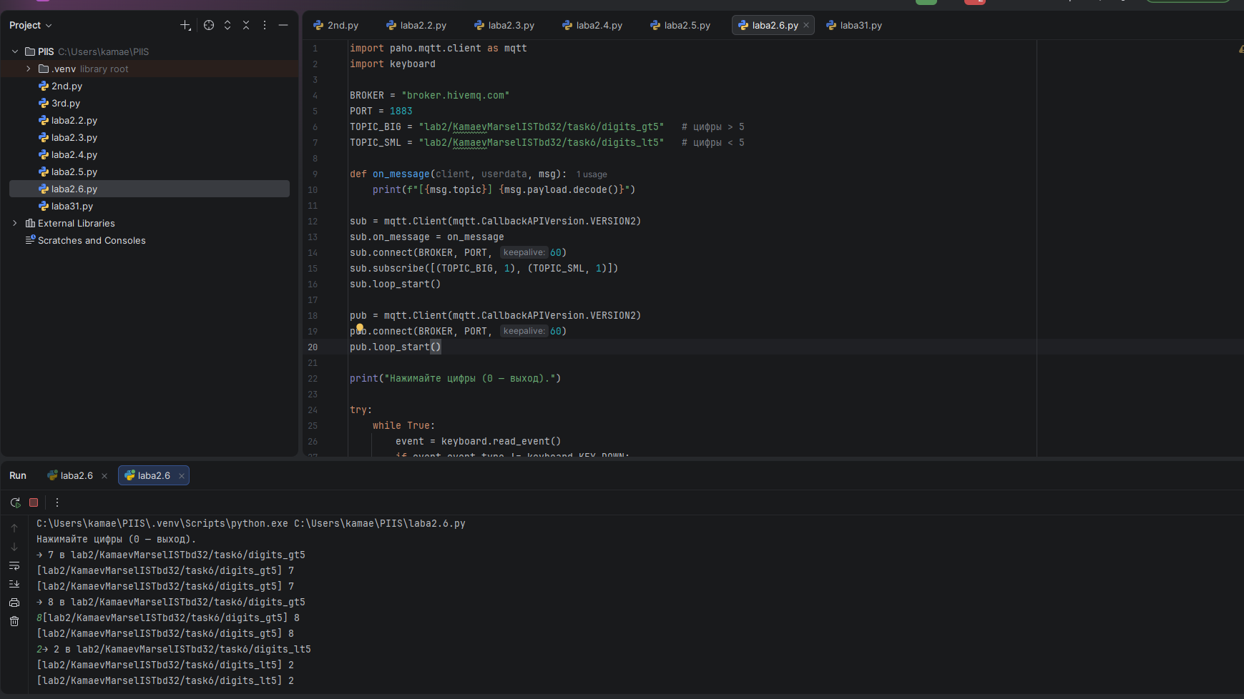
Код:
import paho.mqtt.client as mqtt
import keyboard

BROKER = "broker.hivemq.com"
PORT = 1883
TOPIC_BIG = "lab2/KamaevMarselISTbd32/task6/digits_gt5" # цифры > 5
TOPIC_SML = "lab2/KamaevMarselISTbd32/task6/digits_lt5" # цифры < 5

def on_message(client, userdata, msg):
print(f"[{msg.topic}] {msg.payload.decode()}")

sub = mqtt.Client(mqtt.CallbackAPIVersion.VERSION2)
sub.on_message = on_message
sub.connect(BROKER, PORT, 60)
sub.subscribe([(TOPIC_BIG, 1), (TOPIC_SML, 1)])
sub.loop_start()

pub = mqtt.Client(mqtt.CallbackAPIVersion.VERSION2)
pub.connect(BROKER, PORT, 60)
pub.loop_start()

print("Нажимайте цифры (0 — выход).")

try:
while True:
event = keyboard.read_event()
if event.event_type != keyboard.KEY_DOWN:
continue
key = event.name
if key == "0":
break
if len(key) == 1 and key.isdigit():
d = int(key)
if d > 5:
pub.publish(TOPIC_BIG, key, qos=1)
print(f"→ {key} в {TOPIC_BIG}")
elif d < 5:
pub.publish(TOPIC_SML, key, qos=1)
print(f"→ {key} в {TOPIC_SML}")

finally:
pub.loop_stop(); sub.loop_stop()
pub.disconnect(); sub.disconnect()

ЗАДАНИЕ 7
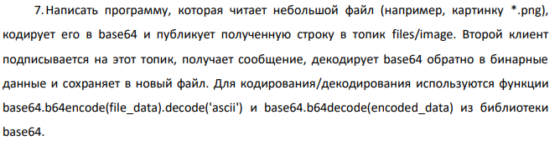
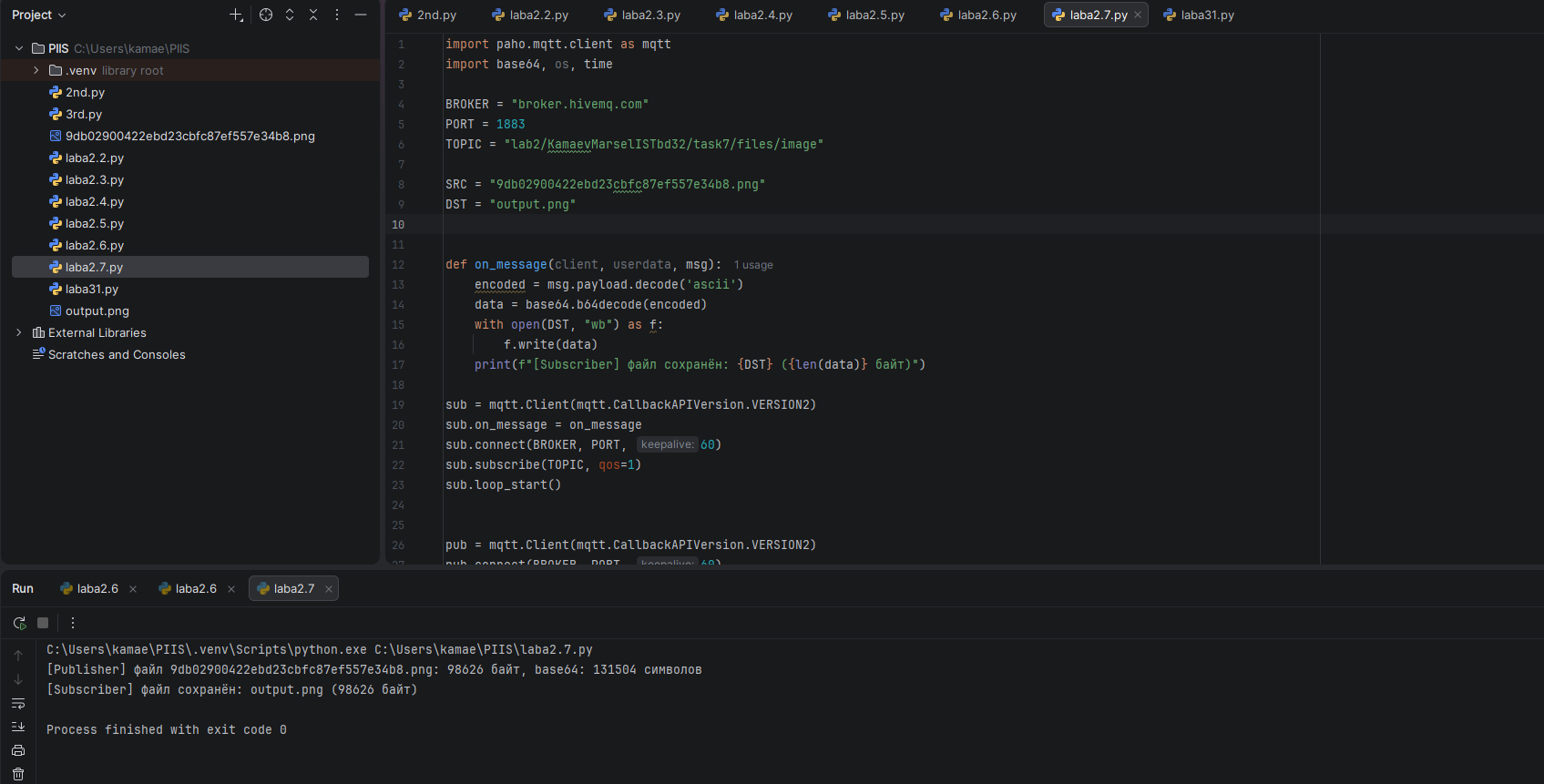
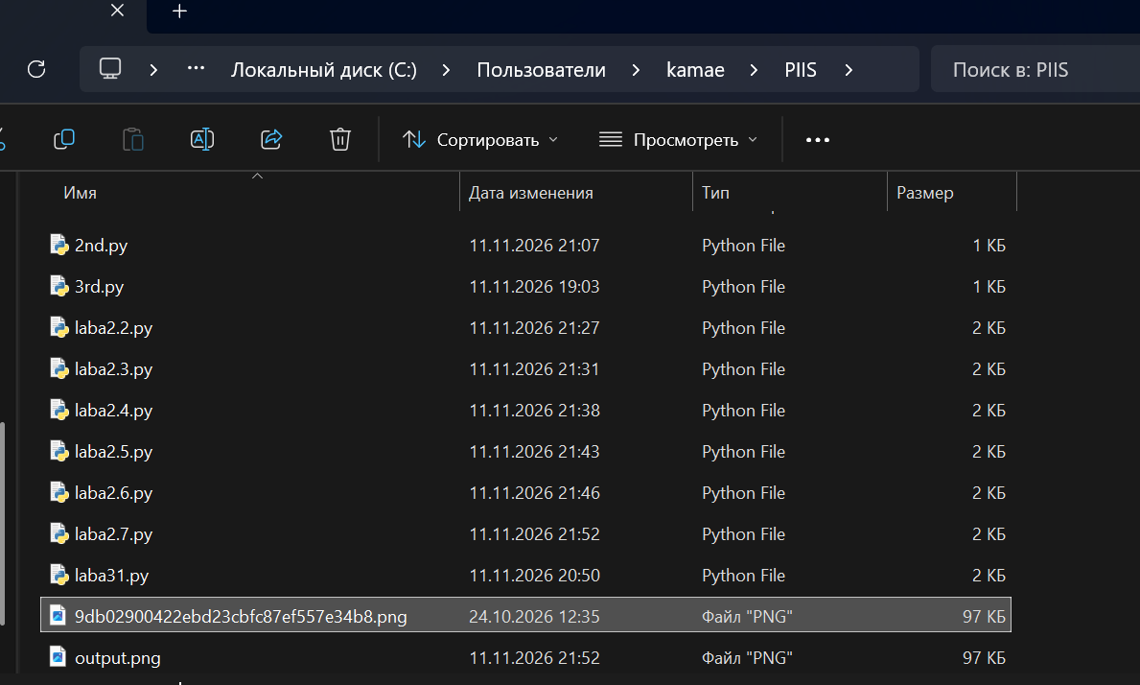
Код:
import paho.mqtt.client as mqtt
import base64, os, time

BROKER = "broker.hivemq.com"
PORT = 1883
TOPIC = "lab2/KamaevMarselISTbd32/task7/files/image"

SRC = "9db02900422ebd23cbfc87ef557e34b8.png"
DST = "output.png"
def on_message(client, userdata, msg):
encoded = msg.payload.decode('ascii')
data = base64.b64decode(encoded)
with open(DST, "wb") as f:
f.write(data)
print(f"[Subscriber] файл сохранён: {DST} ({len(data)} байт)")

sub = mqtt.Client(mqtt.CallbackAPIVersion.VERSION2)
sub.on_message = on_message
sub.connect(BROKER, PORT, 60)
sub.subscribe(TOPIC, qos=1)
sub.loop_start()

pub = mqtt.Client(mqtt.CallbackAPIVersion.VERSION2)
pub.connect(BROKER, PORT, 60)
pub.loop_start()

time.sleep(1) # даём подписчику время подключиться

with open(SRC, "rb") as f:
file_data = f.read()

encoded = base64.b64encode(file_data).decode('ascii')
print(f"[Publisher] файл {SRC}: {len(file_data)} байт, base64: {len(encoded)} символов")
pub.publish(TOPIC, encoded, qos=1)

time.sleep(5)
pub.loop_stop(); sub.loop_stop()
pub.disconnect(); sub.disconnect()

На 2 скрине видно,как сохранилось фото
ЗАДАНИЕ 8
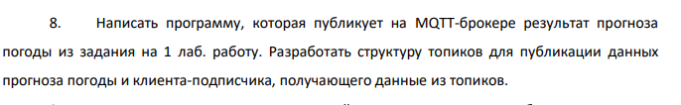
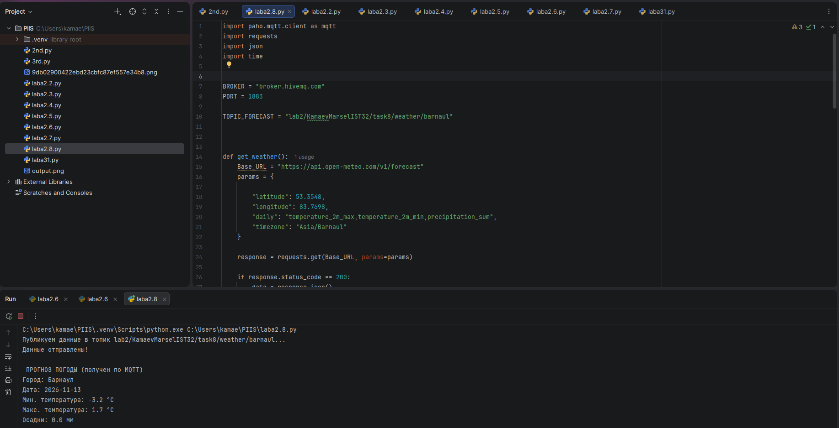
Код:
import paho.mqtt.client as mqtt
import requests
import json
import time

BROKER = "broker.hivemq.com"
PORT = 1883
TOPIC_FORECAST = "lab2/KamaevMarselIST32/task8/weather/barnaul"
def get_weather():
Base_URL = "https://api.open-meteo.com/v1/forecast"
params = {
# Координаты Барнаула
"latitude": 53.3548,
"longitude": 83.7698,
"daily": "temperature_2m_max,temperature_2m_min,precipitation_sum",
"timezone": "Asia/Barnaul"
}

response = requests.get(Base_URL, params=params)

if response.status_code == 200:
data = response.json()

forecast = {
"city": "Барнаул",
"date": data['daily']['time'][1],
"temp_min": data['daily']['temperature_2m_min'][1],
"temp_max": data['daily']['temperature_2m_max'][1],
"precipitation": data['daily']['precipitation_sum'][1]
}
return forecast
else:
print(f"Ошибка API: {response.status_code}")
return None

def on_message(client, userdata, msg):
weather_data = json.loads(msg.payload.decode())

print("\nПРОГНОЗ ПОГОДЫ (получен по MQTT) ")
print(f"Город: {weather_data['city']}")
print(f"Дата: {weather_data['date']}")
print(f"Мин. температура: {weather_data['temp_min']} °C")
print(f"Макс. температура: {weather_data['temp_max']} °C")
print(f"Осадки: {weather_data['precipitation']} мм")

sub = mqtt.Client(mqtt.CallbackAPIVersion.VERSION2)
sub.on_message = on_message
sub.connect(BROKER, PORT, 60)
sub.subscribe(TOPIC_FORECAST, qos=1)
sub.loop_start()

pub = mqtt.Client(mqtt.CallbackAPIVersion.VERSION2)
pub.connect(BROKER, PORT, 60)
pub.loop_start()

time.sleep(1)

forecast_data = get_weather()
if forecast_data:
payload = json.dumps(forecast_data, ensure_ascii=False)

print(f"Публикуем данные в топик {TOPIC_FORECAST}...")
pub.publish(TOPIC_FORECAST, payload, qos=1)
print("Данные отправлены!")

time.sleep(5)

pub.loop_stop()
sub.loop_stop()
pub.disconnect()
sub.disconnect()

ЗАДАНИЕ 9
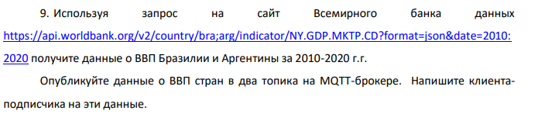
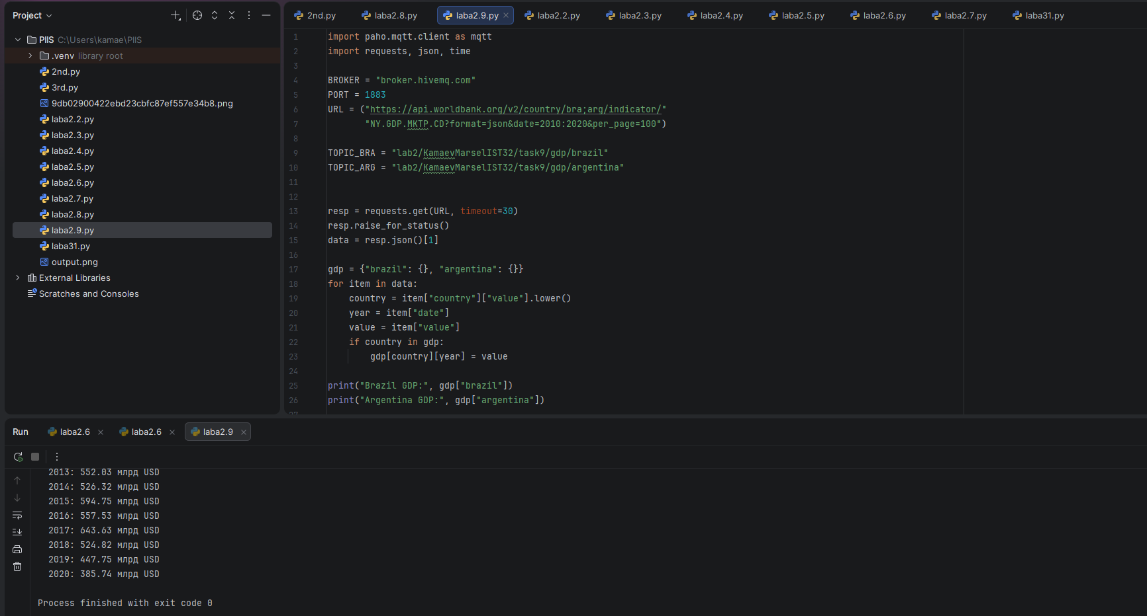
Код:
import paho.mqtt.client as mqtt
import requests, json, time

BROKER = "broker.hivemq.com"
PORT = 1883
URL = ("https://api.worldbank.org/v2/country/bra;arg/indicator/"
"NY.GDP.MKTP.CD?format=json&date=2010:2020&per_page=100")

TOPIC_BRA = "lab2/KamaevMarselIST32/task9/gdp/brazil"
TOPIC_ARG = "lab2/KamaevMarselIST32/task9/gdp/argentina"

resp = requests.get(URL, timeout=30)
resp.raise_for_status()
data = resp.json()[1]

gdp = {"brazil": {}, "argentina": {}}
for item in data:
country = item["country"]["value"].lower() # "brazil" / "argentina"
year = item["date"]
value = item["value"]
if country in gdp:
gdp[country][year] = value

print("Brazil GDP:", gdp["brazil"])
print("Argentina GDP:", gdp["argentina"])

def on_message(client, userdata, msg):
obj = json.loads(msg.payload.decode())
country = msg.topic.rsplit("/", 1)[-1].capitalize()
print(f"\n=== ВВП {country} ===")
for year in sorted(obj):
val = obj[year]
print(f" {year}: {val/1e9:.2f} млрд USD" if val else f" {year}: нет данных")

sub = mqtt.Client(mqtt.CallbackAPIVersion.VERSION2)
sub.on_message = on_message
sub.connect(BROKER, PORT, 60)
sub.subscribe([(TOPIC_BRA, 1), (TOPIC_ARG, 1)])
sub.loop_start()

pub = mqtt.Client(mqtt.CallbackAPIVersion.VERSION2)
pub.connect(BROKER, PORT, 60)
pub.loop_start()

time.sleep(1)
pub.publish(TOPIC_BRA, json.dumps(gdp["brazil"]), qos=1)
pub.publish(TOPIC_ARG, json.dumps(gdp["argentina"]), qos=1)

time.sleep(10)
pub.loop_stop(); sub.loop_stop()
pub.disconnect(); sub.disconnect()
ЗАДАНИЕ 10
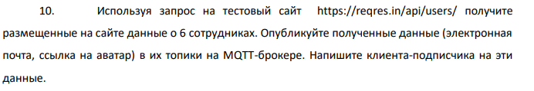
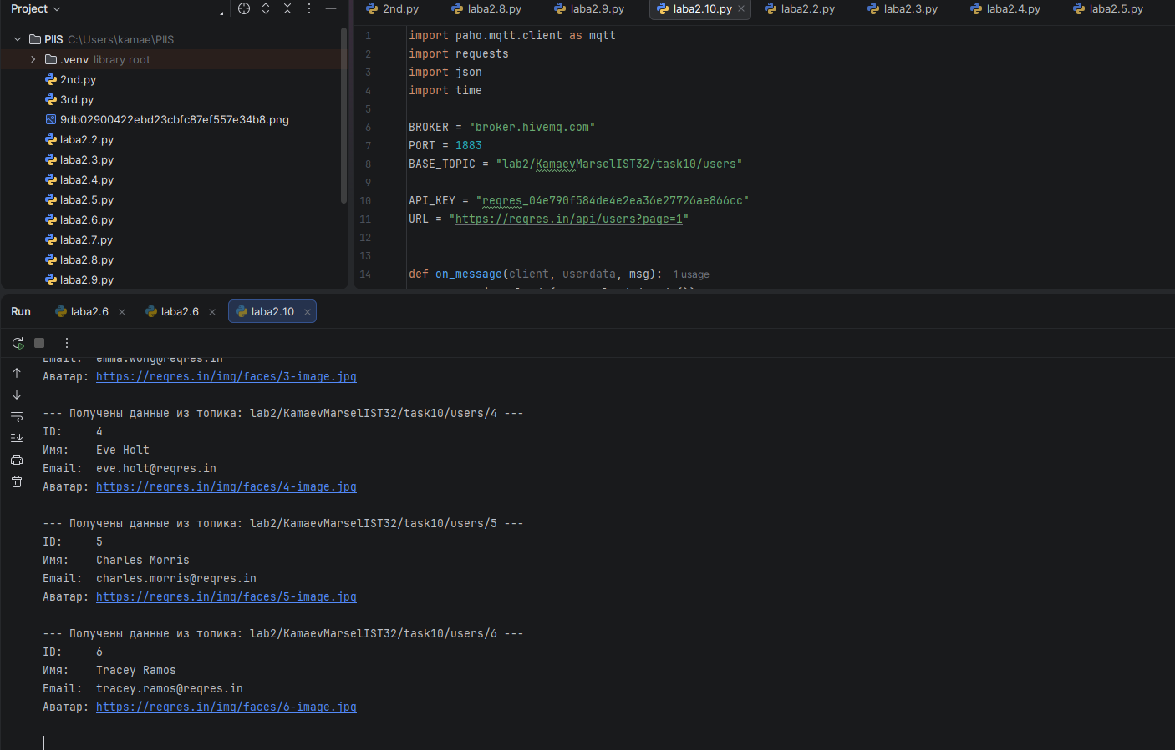
Код:
import paho.mqtt.client as mqtt
import requests
import json
import time

BROKER = "broker.hivemq.com"
PORT = 1883
BASE_TOPIC = "lab2/KamaevMarselIST32/task10/users"

API_KEY = "reqres_04e790f584de4e2ea36e27726ae866cc"
URL = "https://reqres.in/api/users?page=1"

def on_message(client, userdata, msg):
user = json.loads(msg.payload.decode())
print(f"--- Получены данные из топика: {msg.topic} ---")
print(f"ID: {user['id']}")
print(f"Имя: {user['first_name']} {user['last_name']}")
print(f"Email: {user['email']}")
print(f"Аватар: {user['avatar']}\n")

sub = mqtt.Client(mqtt.CallbackAPIVersion.VERSION2)
sub.on_message = on_message
sub.connect(BROKER, PORT, 60)
sub.subscribe(f"{BASE_TOPIC}/#", qos=1)
sub.loop_start()

pub = mqtt.Client(mqtt.CallbackAPIVersion.VERSION2)
pub.connect(BROKER, PORT, 60)
pub.loop_start()

time.sleep(1)

headers = {
"x-api-key": API_KEY
}

print("Запрашиваем данные с reqres.in...")
response = requests.get(URL, headers=headers)

if response.status_code == 200:
data = response.json()
users = data.get("data", [])

print(f"Успешно получено {len(users)} пользователей. Публикуем в MQTT...\n")

for user in users:
topic = f"{BASE_TOPIC}/{user['id']}"

payload = json.dumps({
"id": user["id"],
"first_name": user["first_name"],
"last_name": user["last_name"],
"email": user["email"],
"avatar": user["avatar"]
}, ensure_ascii=False)

pub.publish(topic, payload, qos=1)
print(f"Опубликовано в {topic}")
else:
print(f"Ошибка запроса: {response.status_code}")
print(response.text)

time.sleep(3)

pub.loop_stop()
sub.loop_stop()
pub.disconnect()
sub.disconnect()

ЗАДАНИЕ 11
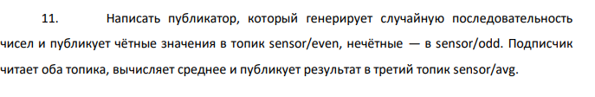
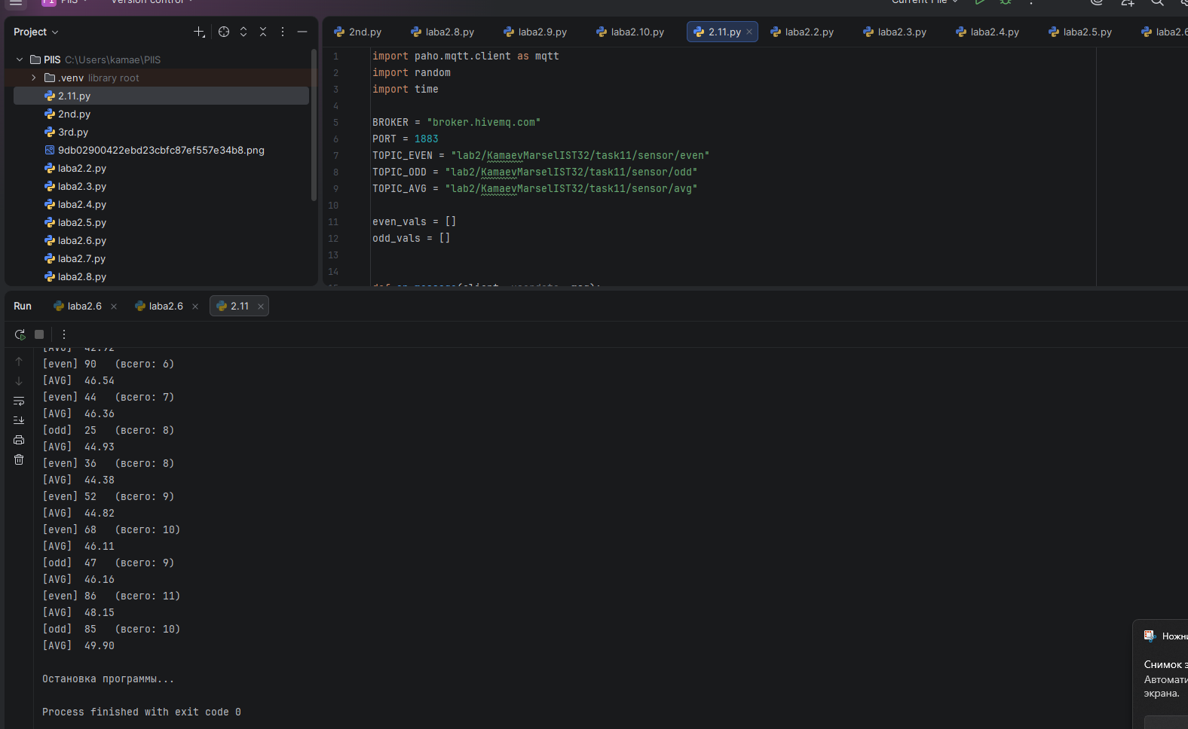
Код:
import paho.mqtt.client as mqtt
import random
import time

BROKER = "broker.hivemq.com"
PORT = 1883
TOPIC_EVEN = "lab2/KamaevMarselIST32/task11/sensor/even"
TOPIC_ODD = "lab2/KamaevMarselIST32/task11/sensor/odd"
TOPIC_AVG = "lab2/KamaevMarselIST32/task11/sensor/avg"

even_vals = []
odd_vals = []

def on_message(client, userdata, msg):
payload = msg.payload.decode()

if msg.topic == TOPIC_EVEN:
val = int(payload)
even_vals.append(val)
print(f"[even] {val} (всего: {len(even_vals)})")
elif msg.topic == TOPIC_ODD:
val = int(payload)
odd_vals.append(val)
print(f"[odd] {val} (всего: {len(odd_vals)})")
elif msg.topic == TOPIC_AVG:
print(f"[AVG] {payload}")
return

if msg.topic in (TOPIC_EVEN, TOPIC_ODD) and (even_vals or odd_vals):
all_vals = even_vals + odd_vals
avg = sum(all_vals) / len(all_vals)
client.publish(TOPIC_AVG, f"{avg:.2f}", qos=1)

sub = mqtt.Client(mqtt.CallbackAPIVersion.VERSION2)
sub.on_message = on_message
sub.connect(BROKER, PORT, 60)
sub.subscribe([(TOPIC_EVEN, 1), (TOPIC_ODD, 1), (TOPIC_AVG, 1)])
sub.loop_start()

pub = mqtt.Client(mqtt.CallbackAPIVersion.VERSION2)
pub.connect(BROKER, PORT, 60)
pub.loop_start()

try:
while True:
n = random.randint(1, 100)
topic = TOPIC_EVEN if n % 2 == 0 else TOPIC_ODD
pub.publish(topic, str(n), qos=1)
time.sleep(2)
except KeyboardInterrupt:
print("\nОстановка программы...")
finally:
pub.loop_stop()
sub.loop_stop()
pub.disconnect()
sub.disconnect()

Вывод:
В результате выполнения лабораторной работы были изучены основы протокола MQTT и реализован обмен данными между клиентами по модели издатель–подписчик.

